

**Faculty of engineering**

Fall 2021

Physics applications project

**Solar Power Bank**

Alhusseain Shalaby - Akram Hany – Amir Anwar

Amir Ashraf – Ekwan Ehab - Albashir Altayeb

Enji Ashraf - Amira Hisham - Omnia Mostafa

Section: 6

ENG/ Mahmoud Mostafa

**Table of Contents**

Task Sheet 3

Literature review 4

Historical Review 4

Methodological Review 7

Theoretical Review 11

Market Research and customer feedback 12

Background 12

Participants and Methodology 13

Key Findings 13

Next Steps and Recommendations 15

A Review on Project compliance with national standards for environmental sustainability 16

References 18

# Task Sheet

|  |  |
| --- | --- |
| **Member** | **Tasks Participated in** |
| **Amir Anwar** | Merging & formatting - market research |
| **Alhusseain Shalaby** | Revisor |
| **Akram Hany** | market research - literature review (theoretical) |
| **Amir Ashraf** | literature review (methodology) |
| **Ekwan Ehab** | market research – literature review (theoretical) |
| **Albashir Altayeb** |  |
| **Enji Ashraf** | Background (research) – Sustainability |
| **Amira Hisham** | Motivation – Sustainability |
| **Omnia Mostafa** | literature review (historical) |

# Literature review

## Historical Review

The first portable power bank was created in 2001 by a Chinese company called Pisin. The original design was two AA batteries pieced together by a circuit! It made its public debut at the Las Vegas International Consumer Electronics Show.

The first power bank was bulky and had a short battery life. Today, there are much more sophisticated and compact designs with far superior battery life. Most modern power banks can fit in the palm of your hand and charge your smartphone several times before running out of battery.

The first power bank was created by the Chinese manufacturer Pisen Technology back in 2004.

In 2005, Pisen produced a new version of the Power King that came with a more sophisticated charging indicator to display the current quantity of battery power being charged. Also, this new model had a much thinner design which made it more portable and convenient to carry around.

In 2006. Early market available concept of a Power Bank

Huaqi officially launches the very first power bank products on the market, initially dubbed as “Engine Compartment”. Around that time, market for power bank started appearing, with other brands such as Aigo and Anytone being launched. The development in the applicable battery, IC, management circuit and related technologies eventually made the power bank more advanced and industry more developed. Domestic market shows promising response, leading companies to branch out to foreign market.

(2006–2009) Market development stage

1st Generation iPhone

More and more Original Equipment Manufacturer (OEM) companies entered the field of power banks industries, breeding competition in the market.

Furthermore, this was also the time where smartphones started to enter the market. In 2007, Apple launched the iPhone, its stylish product design and powerful software features took the market by storm. And in just a few years, the iPhone as the first smart phone brand, grew to ship globally.

Despite of all the hype however, the iPhone is known to have poor battery capacity, with its built-in lithium batteries generally lasting only four hours. This leads to an increase in demand for custom mobile power banks. Many Apple authorized manufacturers and authorized mobile power brands that are known for producing highly specialized iPhone/iPad mobile power begun to emerge. The iPhone external battery development has become the trend. There were around 50 brands of power bank around this period.

Market growth stage (2009–2012)

The power banks market grew exponentially, with over 500 brand on the market. New research and innovation lead to a competitive power bank market and we now have the different brands and power options to choose from, making this device even more popular among people.

Today, Pisen Technology goes by the name Anker Technology, which is the global leader in charging technology and an internationally renowned enterprise. Millions of people that are all around the world are using Anker power banks, as they are very reliable, high-quality gadgets that come at a very decent price

The first model of the Power King was a very heavy, inconvenient, and bulky-looking charging device that weighed a little over 2 pounds. It kind of looked like a chunky small radio device with a USB output.

However, the second version already had a much thinner design which made it more portable and convenient to carry around.

That model “only” weighed 1 pound, which was a huge improvement at the time, given the technological know-how and the designs available.

The dimensions of this second-generation power bank were as follows: 174 mm x 68 mm x 37 mm (6.85 inches x 2.67 inches x 1.45 inches). Those power bank dimensions became the industry standard for many years and models to come.

Other major differences between power banks then and now are both weight and dimensions. Nowadays, power banks are extremely small and compact and can weigh as little as 120g (4 ounces) and measure a mere 100mm x 50mm x 30mm (4 inches x 2 inches x 1.3 inches).

And then there is the difference in charging capacity. The first power banks had a very short battery life and a charging capacity below 1000 mah.

Today, power banks are highly technological and evolved gadgets with long battery life and charging capacities that can exceed 20000 mah. And that’s only the beginning. In the near future, these numbers will be dwarfed by even more sophisticated models and technologies, as the industry around lithium batteries is developing at an ever-faster rate.

The first power banks were mostly used by professional photographers who needed a portable charging device for their cameras/flashlights/phone batteries.

Nowadays, power banks have become a necessity in everybody's life. A good power bank is a great tool to avoid the embarrassment of a mobile phone that is about to power off because of insufficient charge. Many people, perhaps, don't know that 99% of power banks are made in China, including those from famous brands such as Anker and Belkin. Most of the time, R&D is also based in China.

One of the largest power bank manufacturers, Pisen, has been chosen by over 20 million customers all over the world. The company is also the biggest 3C digital manufacturer in China.

Pisen - Power Bank Inventor

What very few people know, though, is that Pisen is also the inventor of power bank.

In 2004, a Chinese "7+2" Antarctic Expedition Team asked Pisen to provide specific digital equipment for their trip. The team needed a portable charger that could charge video cameras and other electronic devices. Normal camera batteries lose their capacity quickly under extremely cold temperatures. For instance, a battery, capable of charging for an hour, would only charge for few minutes.

The invention of a bigger battery that could charge various camera batteries became the solution. That was the first power bank ever invented, called "Mini Power Bank" or "Power King".

## Methodological Review

Construction & The Working Principle of Solar Cells

It consists mainly of a PN junction and we connect it with load. At night no electrons flow from the N-region to the P-region due to the presence of depletion region while in the morning Sun light fall on the solar cells and it is absorbed by photovoltaic cells. In the structure of solar cells, most of the electrons are included in n-type semiconductor material while most of the electron's hole included in p-type semiconductor material. Sun light breaks electron from the n-type semiconductor material. Energizing electrons flow of p-type to the n-type semiconductor material via an external circuit. This constant and unidirectional flow of electrons forms Direct Current (DC). Electrons flowing through the founded circuit which is used for the charging of batteries

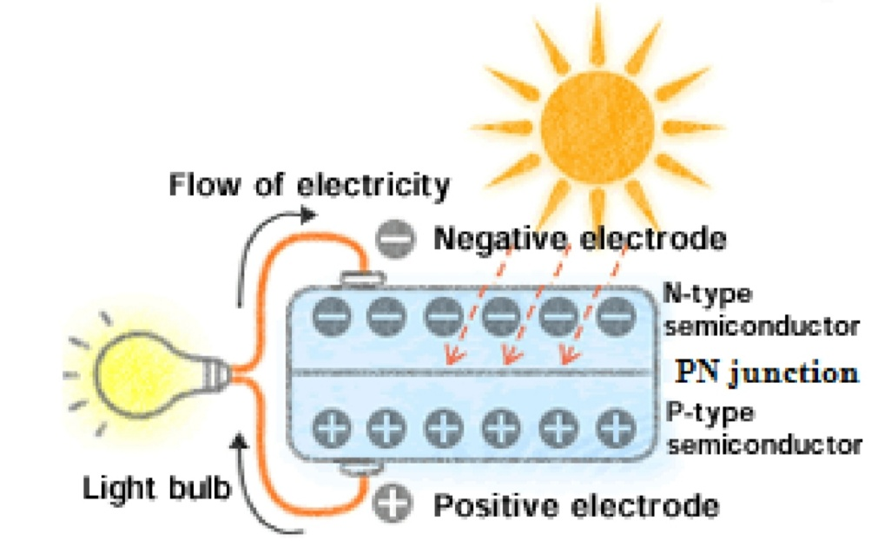

**I-v , p-v Characteristics of solar cell**

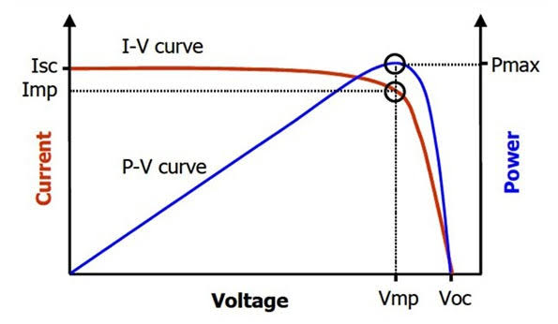

From this graph we get the Pmax which also called P(DC) STC

“Standard test conditions” and at STC there are two conditions 1.Tcell=25°c

2. Psun = 1 Kw/m^2

**Factors affecting photovoltaics (pv)**

1.temp

A reduction in the Poutput takes place = 0.5%/°c (for every increase above 25°c)

Tcell = Tambient +

NOCT (normal operating cell temperature) : it is the Tcell when solar radiation Ps = 0.8 and Tambient =20

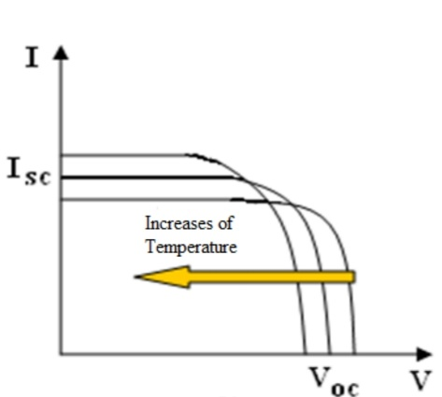

The current increases due to breaking more carriers but the voltage decreases with a bigger rate which leads to decrease in the Poutput

**2.solar radiation Ps**

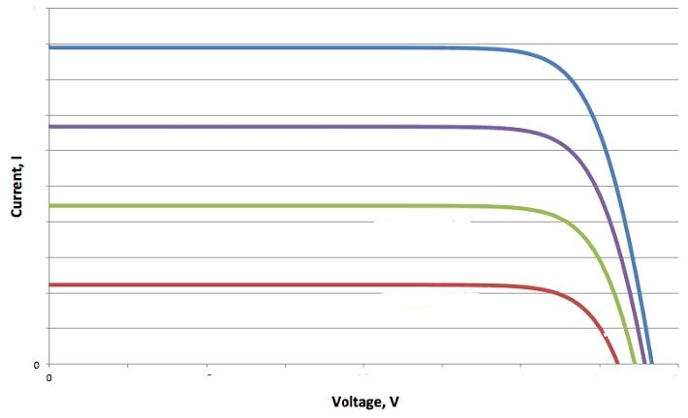As the solar radiation increases the current intensity increases and the voltage is constant

Psun∝I

Pcell = IV

Pcell ∝ I ∝ Psun

So efficiency of cell : η =

**3.Dust**

As dust increases as the surface area of the cell exposed to sun decreases so Poutput decreases

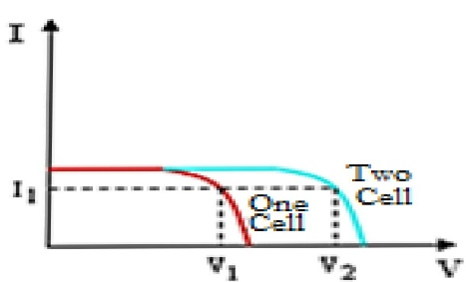**4.Connection of cells**

**Series**

Intensity is constant

Voltage = V × n (no. of cells)

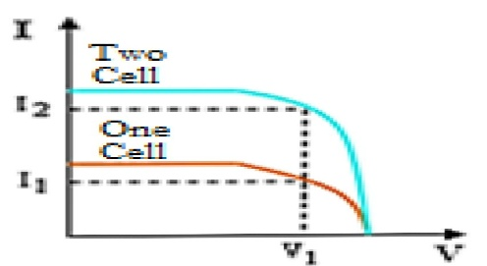**Parallel**

Voltage is constant

Intensity = I × n (no. of cells)

**ELECTRICAL SPECIFICATIONS OF SOLAR CELLS**

**Equivalent circuit:**

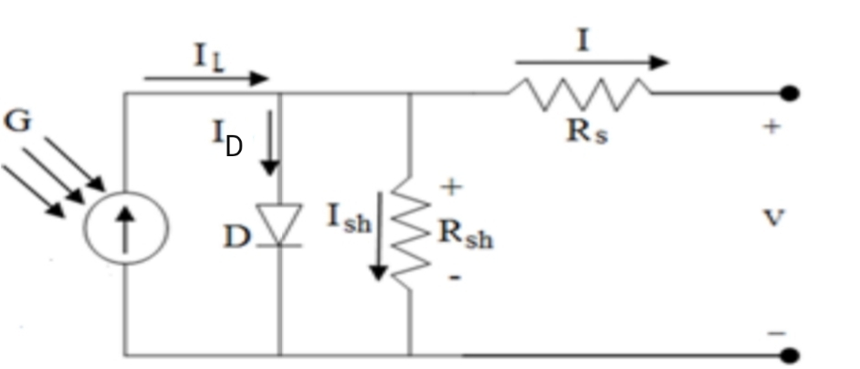

**Intensity**

I = IL – ID – Ish

ID = Io(

parameters are; the Boltzmann constant (k), the electron charge (q) and the temperature of the solar cell (T).

I = IL– Io(

(n) : diode quality “ideality factor ” and it depends on the element which the semiconductor is made from and the doping concentration n= range (1-5)

We get I by trial and error

Or we use an approximate equivalent circuit

By putting Rs=0 , Rsh = ∞ , n=1

So I= IL - Io(

Ish = IL

At open circuit

0 = Is.c - Io(

Is.c = Io(

Vo.c = Vt ln(1+)

## Theoretical Review

Solar power bank is a solar based device in which solar panels play a vital role. When the solar panels are open, sunlight directly falls on the photovoltaic cell of the panel which converts the solar energy to electrical energy. We have two solar panels each of 6V, for receiving the sunlight, which is connected to the battery of the system where the charge from the sun is stored for future use. The battery is also of 12V with three 4V batteries connected in series. Then, the battery is connected to the mobile charging circuit which is further connected to a USB port from where a mobile can be connected for charging. There are two relay circuits, one attached between the solar panel and the battery and other one attached between the battery and the mobile phone which is controlled by the microcontroller. The microcontroller is the brain of the whole circuit as it checks and allows the required amount of flow of charge from one end to another. If at any point, we might get low or high voltages, then the microcontroller signals the relays and the relays cut the connection by switching off to protect the appropriate elements like the transistor, resistor etc.

# Market Research and customer feedback

## Background

Solar energy has evolved as a major alternative source of energy. Solar energy is increasingly being utilized as source of energy for street lighting, automobiles, house appliances and others. In recent times, solar power banks are gaining popularity in the consumer market, with the rise in use of electronic gadgets. Solar power banks serve as an energy storage device, which can be utilized when required to charge any of the USB-charged devices.

Solar power banks require sunlight to charge, making it reliable in circumstances where electrical supply or charger is not available. Most of the solar power banks available today can be charged alternatively via computer using USB. Considering solar as an environmentally friendly technology, demand for solar power banks is expected to escalate in the coming years. (1)

The key companies operating in solar power bank market include Anker., Advantage Computers, LG Chem, China BAK Battery, Inc., Mophie Inc., Microsoft Corporation, Panasonic Corporation, OnePlus, Sony Corporation, Samsung SDI Co., UNU ELECTRONICS INC., Xiaomi Technology Co., and Shenzhen Topband Co.

In this report we will try represent a comprehensive assessment of the market trying to identify the thought process of the target costumer, what matters more to them the price or the quality, what extra features would they find more appealing and what is the expected price range.

|  |  |
| --- | --- |
| Strengths:   * Sustainability * Competitive price range with respect to capacity | Weaknesses:   * Bad aesthetics |
| Opportunities:   * The need for renewable portable power sources in increasing | Threats:   * New companies face a hard time gaining a market share against the established competitive ones. |

## Participants and Methodology

We conducted a survey on 60 people to determine the most important factors and criteria when designing our product. We ran the survey online. The questions were about the product, pricing and demand. We were trying to determine: the most important factor to consider while designing the solar power bank, what are the extra features that could attract more target customers, the demand and the expected price range. here are the results.

## Key Findings

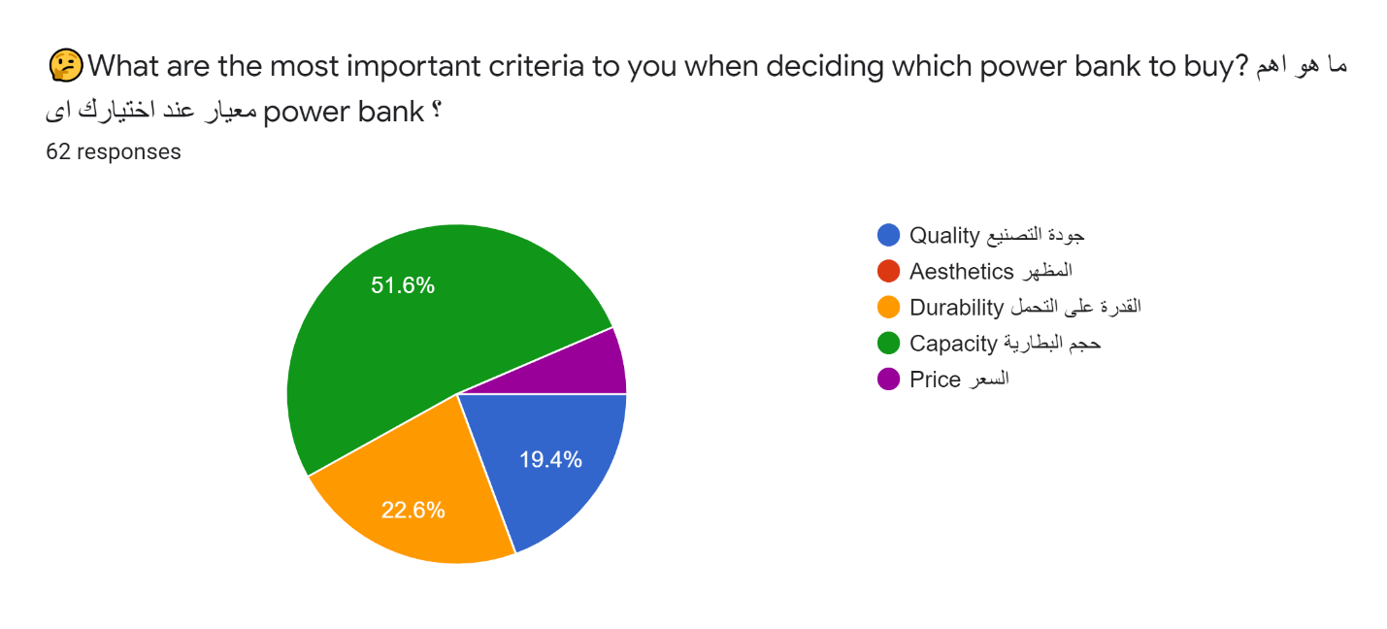

In this question we found that the most important factor while designing a power bank is its **capacity**.

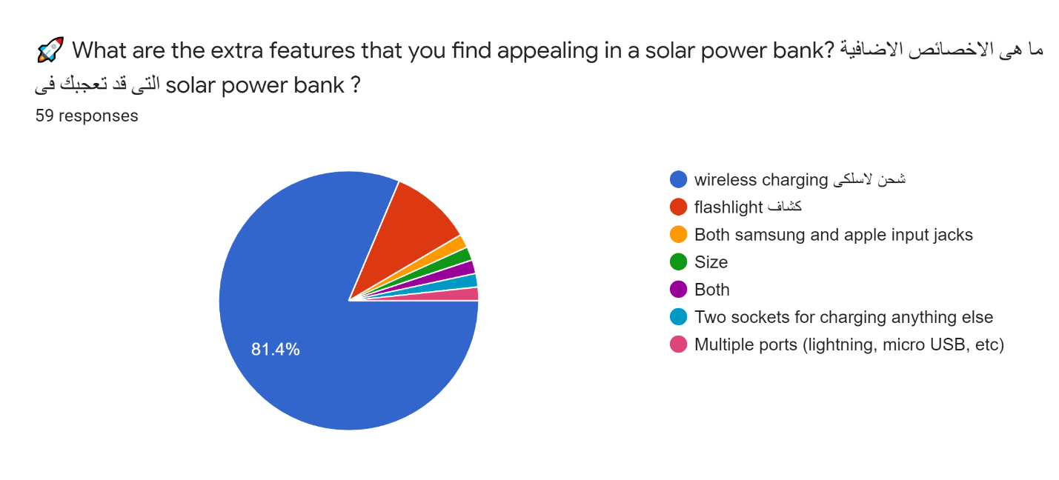

Some extra features suggested by the participants:

* Wireless charging
* Flashlight
* Having considerably small size
* Multiple output ports

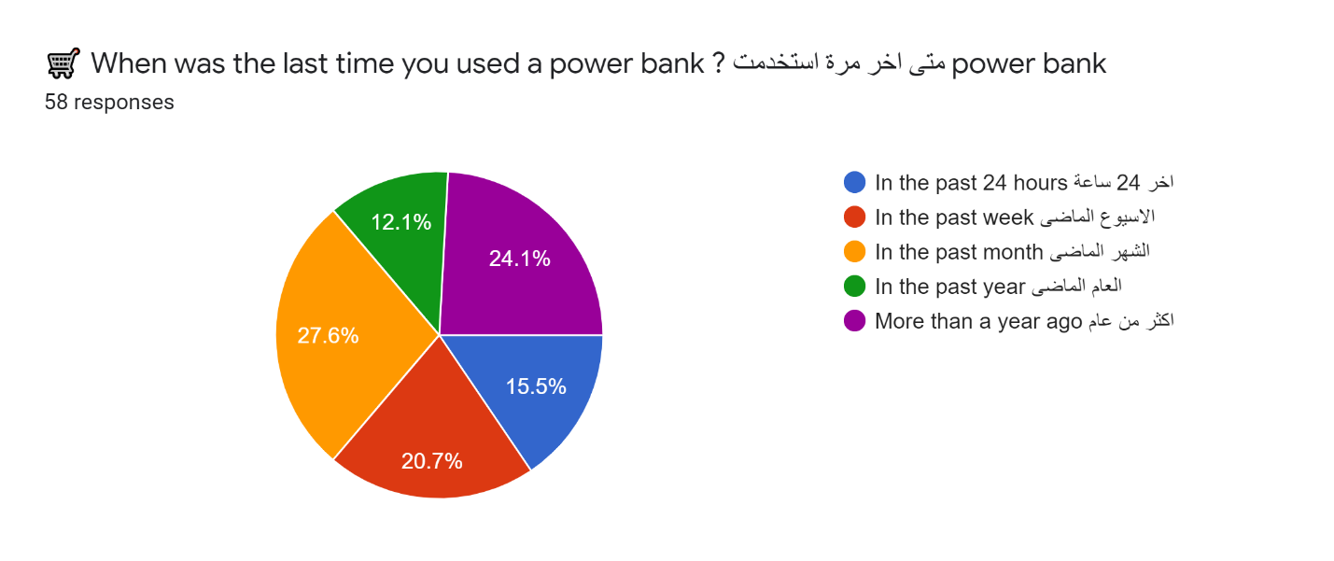here we found that at the last month 63.8% of the participants has used a power bank at least once. Which is a indication of high demand.

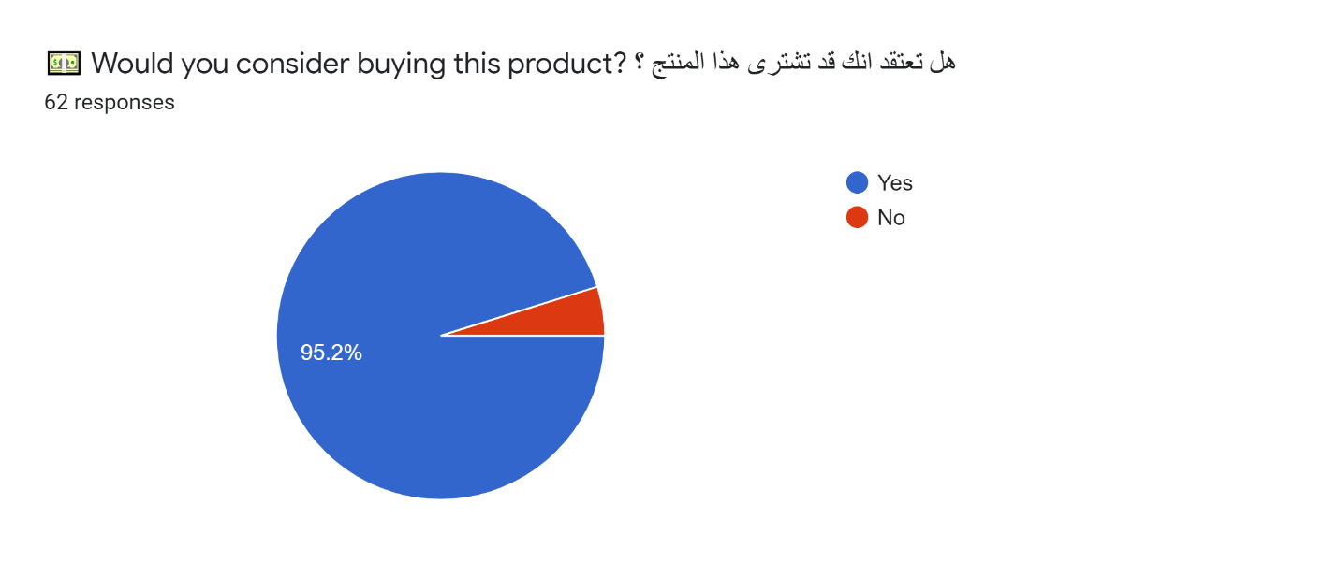The results here also indicate a high demand and induces a high growth rate.

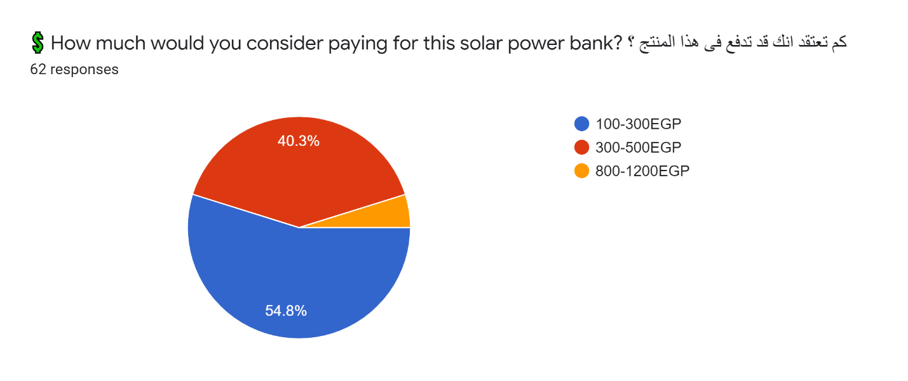

here we found a fascinating result that a 45% of the participants estimated the price range to be more than the actual. This gap between expectation and reality can be turned into profit.

## Next Steps and Recommendations

1. We should focus on having a bigger capacity battery with as small size as possible.
2. We should try to implement some of the suggested features:
   * Wireless charging
   * Flashlight
   * Having considerably small size
   * Multiple output ports

# A Review on Project compliance with national standards for environmental sustainability

The environment around us is not only our home but everything that keeps us alive. Therefore, caring for the environment is something that should be inherent in us.

Although electricity is a basic human need and an essential part of modern life, generating electricity has harmful effects on environment. Traditional electricity is sourced from fossil fuels such as coal and natural gas. When fossil fuels are burned to produce electricity, they emit harmful gases that are the primary cause of air pollution and global climate change. Not only are fossil fuels bad for the environment, but they are also a finite resource. Therefore, the world is turning its focus to cleaner power and sustainable energy. Since then, solar energy has witnessed a significant rise in importance. (2)

Comparatively to conventional energy sources, solar energy systems offer significant environmental benefits. The sun is a huge source of energy that provides immense resources which can generate clean, non-polluting and sustainable electricity.

Even in terms of manufacturing, solar power banks outweigh conventional ones in terms of emissions specifically. Although chemicals are used, they are insignificant when we say that energy is recouped in less than 2 years and a low negative environmental impact. (3)

The potential environmental impacts associated with solar power can be classified into many categories, some of which are water use, heavy metals, local air quality and global warming emissions. (4)

1- **Water use**

Solar PV cells do not use water for generating electricity. However, as in all manufacturing processes, some water is used to manufacture solar PV components (used for cooling). There is also dry-cooling technology that can reduce water use by approximately 90% but it is less effective at temperatures above 100 degrees Fahrenheit. (5)

2-**Heavy Metals**

Although solar panel manufacturing uses dangerous materials such as Cadium Telluride, coal power plants emit much more of these toxic substances, polluting up to 300 times more than solar panel manufacturers, so solar panel is relatively much better. (4)

3- **Global warming emissions**

Generating electricity with solar power instead of fossil fuel can dramatically reduce greenhouse gas emissions. If we compare direct emissions from the production of cadmium telluride cells with coal power plants, toxic emissions would score about 300 times lower. (5)

4-**Local air quality**

One of the biggest benefits of solar energy is that it results in very few air pollutants as it can significantly reduce nitrous oxides, sulfur dioxide, and particulate matter emissions. (4)

# References

1. **Solar Power Bank Market - Global Industry Analysis, Size, Share, Growth, Trends and Forecast. *transparencymarketresearch.* [Online] https://www.transparencymarketresearch.com/solar-power-bank-market.html.**

**2. Holowka, Taryn. Top four benefits of installing solar panels on your home. *usgbc.* [Online] https://www.usgbc.org/articles/top-four-benefits-installing-solar-panels-your-home.**

**3. The Positive and Negative Environmental Impacts of Solar Panels. *kubyenergy.* [Online] https://kubyenergy.ca/blog/the-positive-and-negative-environmental-impacts-of-solar-panels.**

**4. https://www.greenmatch.co.uk/blog/2015/01/impact-of-solar-energy-on-the-environment. *greenmatch.* [Online] https://www.greenmatch.co.uk/blog/2015/01/impact-of-solar-energy-on-the-environment.**

**5. Environmental Impacts of Solar Power. *ucsusa.* [Online] https://www.ucsusa.org/resources/environmental-impacts-solar-power.**

**6. Energy Efficient: Why You Should Get a Solar Powerbank. solaric. . [Online] https://solaric.com.ph/blog/why-get-solar-powerbank/.**

**7. Zafar, Salman. What is a Solar Power Bank? . *ecomena.* [Online] https://www.ecomena.org/what-is-a-solar-power-bank/.**

**8. What Are PV Panels? *greenmatch.* [Online] https://www.greenmatch.co.uk/blog/2014/08/what-are-pv-panels.**

**9. IS SOLAR POWER WORTH THE INVESTMENT? *solarbyempire.* [Online] http://solarbyempire.com/why-solar/solar-panel-efficiency.**

**10. C, Tim. How Many Amps Does a Solar Panel Produce? *altenergyoptions.* [Online] https://altenergyoptions.com/how-many-amps-does-a-solar-panel-produce/.**

**11. Lee, Samanth. Best Solar Power Banks: Solar Charger Power Bank (Solar Powered Battery Bank. *ecavo.* [Online] https://ecavo.com/best-solar-power-banks/.**